|  |  |
| --- | --- |
| ***­­­­­­Documentation for Cotiss*** |  |

**Project:** Cotiss Feedback Website

**Version:** Version 1.0

**Date:** 15/01/2023­

## *Company Overview*

Cotiss is built specifically to help organisations be more effective in how they buy & supply goods and services. They’re a B2B company that creates software for companies to track their spending and make better business decisions.

## *Project Objective*

To encourage Costiss Employees and Customers to share honest feedback on their new Feedback website which will help company to improve their services.

## *Website Features*

* Simple UX design.
* Randomly selected feedback to be displayed on the website on each page load.
* Customers and Employees will be able to submit feedback anonymously on the same page.
* Users are encourage to post feedback anonymously to increase the service standards of the company.

***Honest Feedback Website***

***Project Technical Details***

Project is build using Azure Services and below are the technical steps which was involved during the different stages of the development.

***Account Basics***

Steps involve to set up basics accounts:

To create an IAM (Identity and Access Management) user for your personal use, follow these steps:

1. Sign in to the Azure portal.
2. Navigate to the Azure Active Directory.
3. Select "Users" from the left menu.
4. Click "New User" button.
5. Enter the user's name, email address, and role (e.g. "User" or "Global administrator").
6. Click the "Create" button.

To set up MFA (multi-factor authentication) follow these steps:

1. Sign in to the Azure portal.
2. Navigate to the Azure Active Directory.
3. Select “User” from the left menu.
4. Select "Per-User MFA" from the top menu.
5. Select the specific user and enable/disable the MFA.

To set up billing alerts for anything over a few dollars, follow these steps:

1. Sign in to the Azure portal.
2. Navigate to the "Cost Management + Billing" section.
3. Select “Cost Management”.
4. Select "Cost Alerts" from the left menu.
5. Click the "Add" button.
6. Follow the prompts (select percentage to be alerted and email address) to set up the billing alert.

To configure the Azure CLI for your user follow these steps:

*You can use the Azure CLI to retrieve information about your Azure account.*

1. Install the Azure CLI on your local machine.
2. Run the **az login** command and follow the prompts to authenticate with your Azure account.
3. If you have multiple subscriptions associated with your account, run the **az account set --subscription SUBSCRIPTION_ID** command to select the desired subscription.
4. You can now use the Azure CLI to manage your Azure resources

***Web Hosting Basics***

Deploy a Virtual Machine (VM):

1. Sign in to the Azure portal.
2. Click the "Create a resource" button.
3. Search for "Virtual Machine" and select it from the list of resources or select create new group.
4. Click the "Create" button.
5. Follow the prompts to create the VM, making sure to select an appropriate size and region.
6. Click “Create” button.

To take a snapshot of your VM, delete the VM, and deploy a new one from the snapshot, follow these steps:

1. Sign in to the Azure portal.
2. Navigate to the Virtual Machines section.
3. Select the desired VM (Select “Disk”, select a snapshot).
4. Click the "Create snapshot" button.
5. Follow the prompts to create the snapshot.
6. Once the snapshot has been created, delete the original VM.
7. Click the "Create a resource" button.
8. Search for "Virtual Machine" and select it from the list of resources.
9. Click the "Create" button.
10. Follow the prompts to create a new VM, selecting the snapshot as the source.
11. Once the new VM has been deployed, test it to ensure that it is functioning properly.

***Create Snapshot***

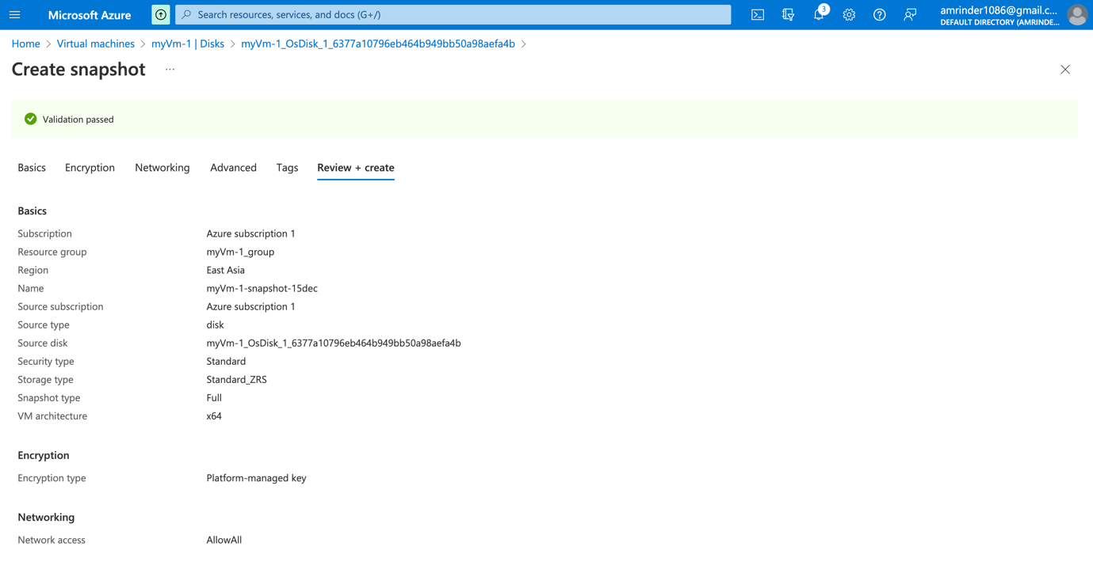

***Create Disk***

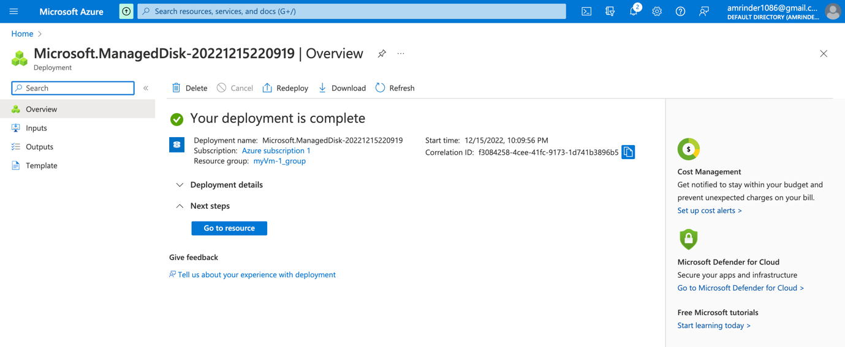

***Create VM from Disk***

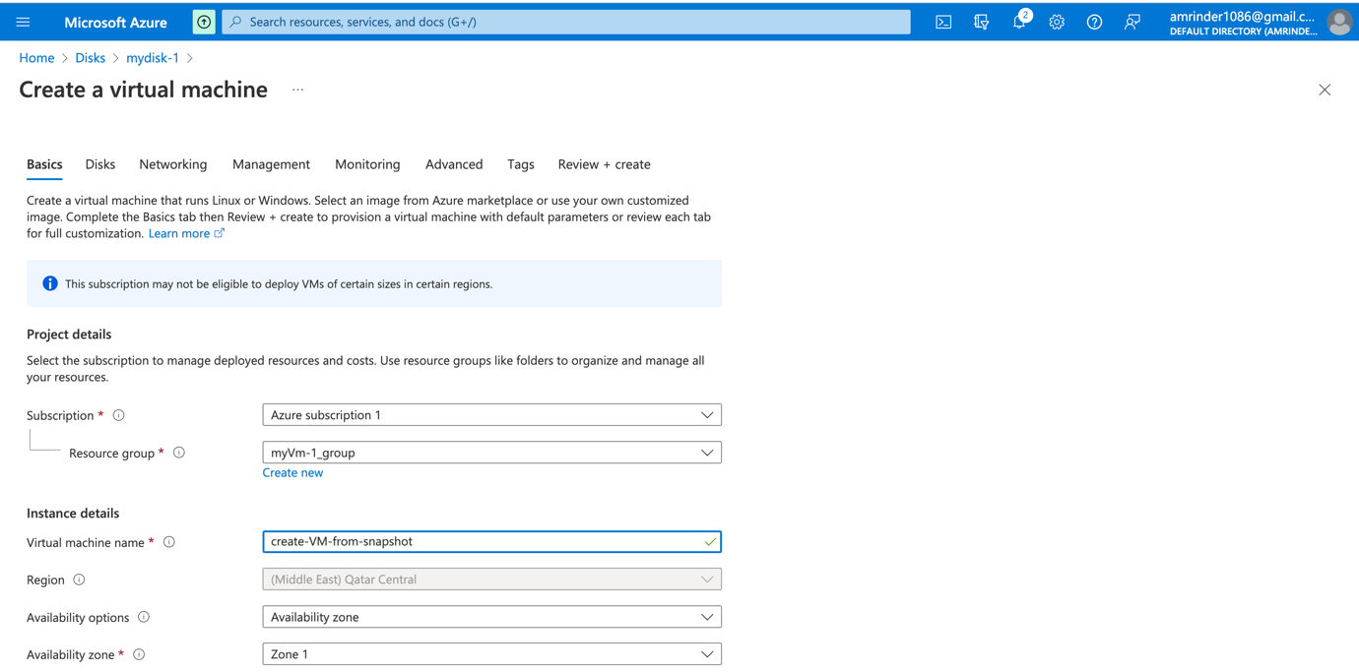

***Auto Scaling***

To set up auto scaling in Azure, you will need to use an Azure Load Balancer to distribute incoming traffic between two or more Virtual Machine (VM) instances. This will ensure that your website is still accessible even if one of the VMs becomes unavailable.

To set up an Azure Load Balancer in front of your VMs and load balance between two Availability Zones (one VM in each Availability Zone), follow these steps:

1. Sign in to the Azure portal.
2. Click the "Create a resource" button.
3. Search for "Load Balancer" and select it from the list of resources.
4. Click the "Create" button.
5. Follow the prompts to create the Load Balancer, making sure to select an appropriate region and configure the Load Balancer to balance traffic between the two Availability Zones.
6. Once the Load Balancer has been created, create two VMs in different Availability Zones and assign them to the Load Balancer.

Top of Form

***Load Balancer***

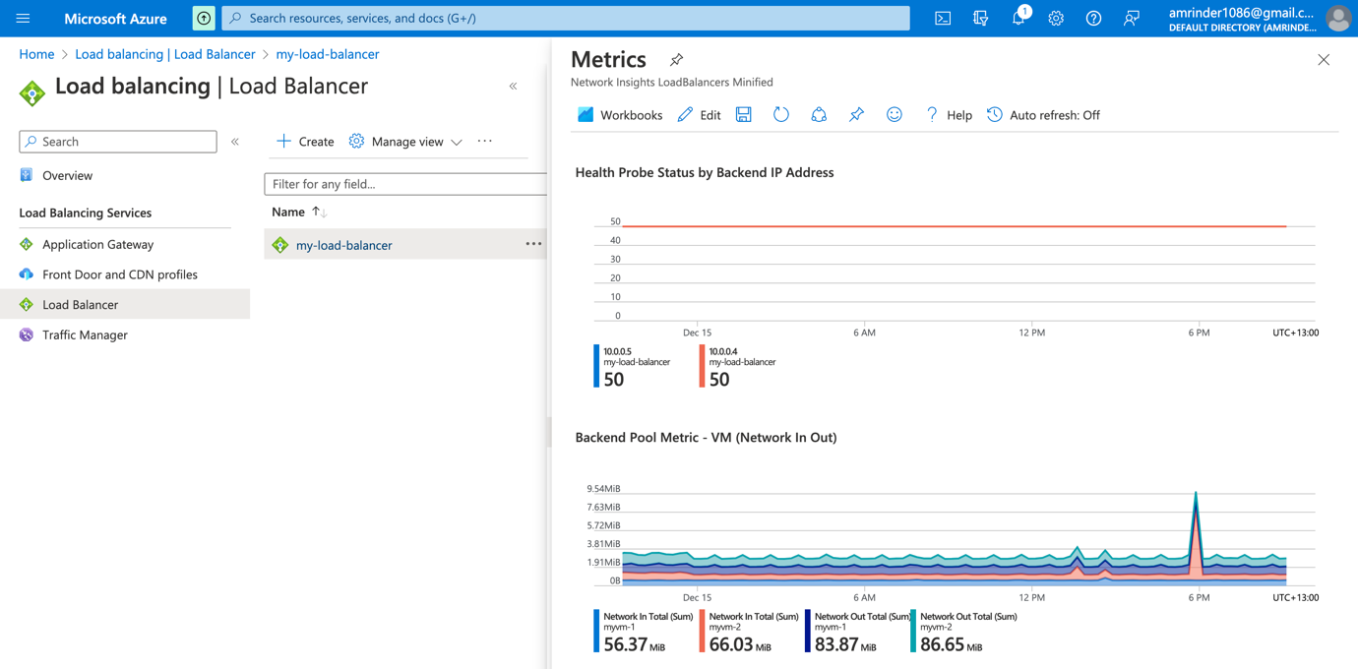

***External Data***

To enable your auto scaled website to load and save data to a database, you can use Azure Cosmos DB.

To create an Azure Cosmos DB account and experiment with loading and retrieving data, follow these steps:

1. Sign in to the Azure portal.
2. Click the "Create a resource" button.
3. Search for "Azure Cosmos DB" and select it from the list of resources (Create Mongo Db account).
4. Click the "Create" button.
5. Follow the prompts to create an Azure Cosmos DB account.
6. Once the account has been created, navigate to the Azure Cosmos DB account in the Azure portal (Go to resources after deployment).
7. Click the "Data Explorer" button.
8. Click the "Add Container" button (Enter Container name (database name) and then container Id).
9. Once the table has been created, you can use the Data Explorer to manually load and retrieve data from the table.
10. Select “Connection String” from the left menu, copy and use it to connect website with the database.

***Cosmos DB Account***

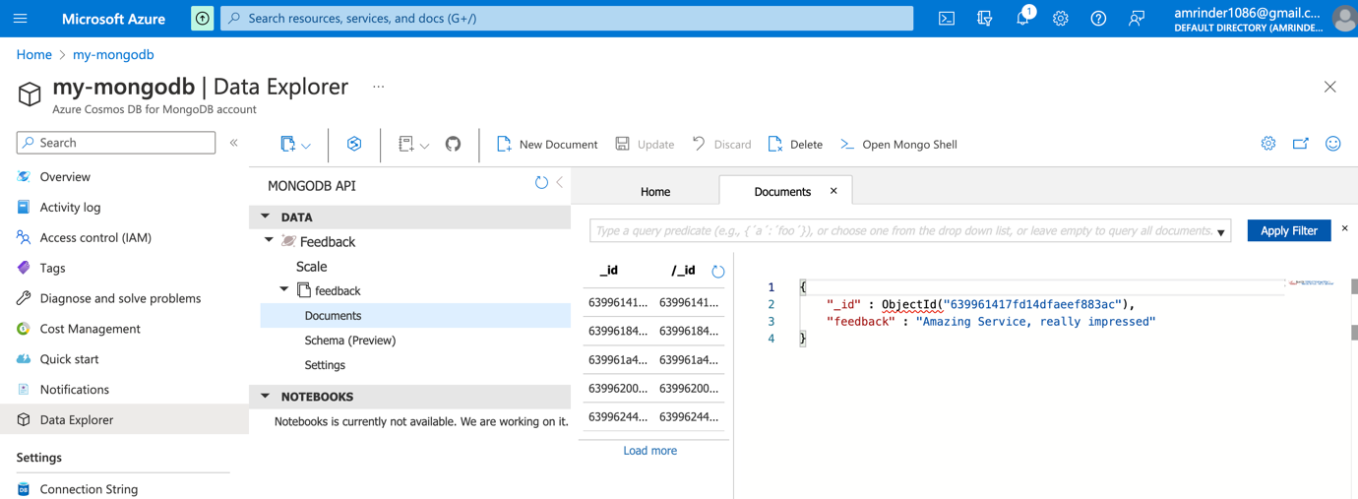

***Deployment***

Please check the repository link below for the code

**Git Hub Repository:** <https://github.com/asin211/azure-random-feedback>

**Honest Feedback website can reads and updates a list of feedback entries in the Azure Cosmos DB table.**

***Honest Feedback Website***

***Deployed Website***

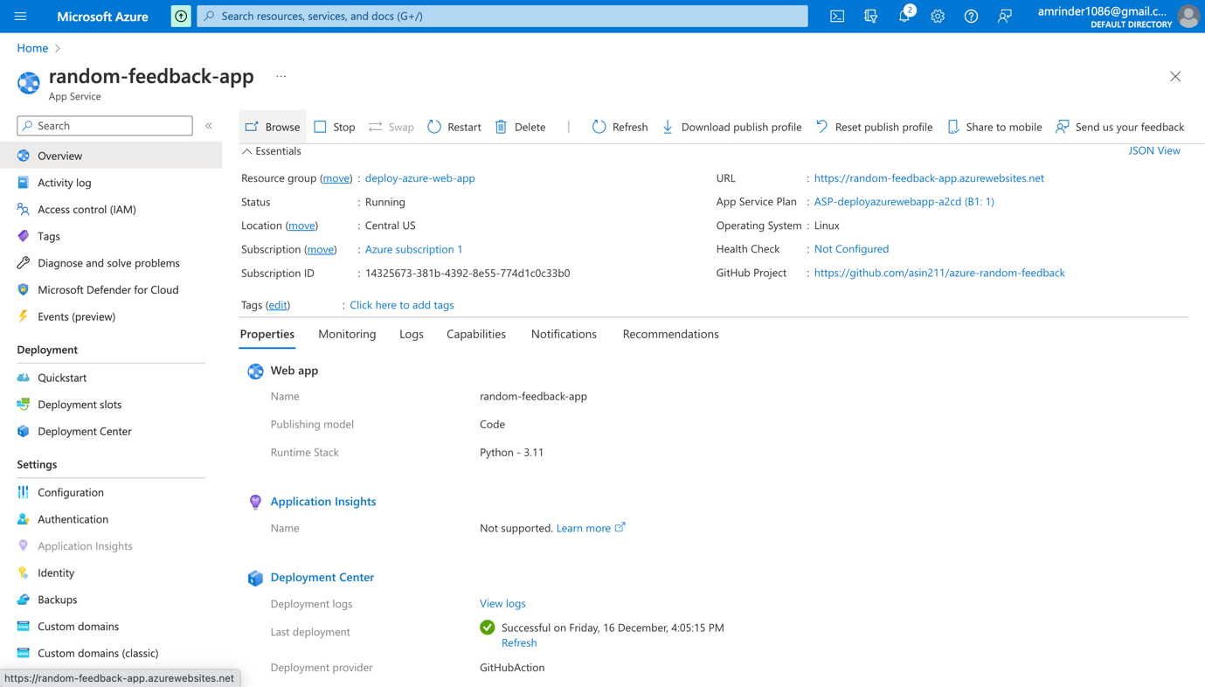

***Cost Analysis***

**Roughly Monthly Cost:** $50-$100

**Scaling this architecture and how it will affect would my costs:**

* Types of Resources: The types of resources, such as virtual machines, containers, or serverless functions, can affect the scalability and cost of your architecture.
* Resources sizes: The sizes of the resources, such as the number of CPU or the amount of memory, can also affect the scalability and cost of your architecture.
* Resource usage patterns: The usage patterns of your resources, such as the number of requests they handle or the amount of data they process, can influence the scalability and cost of your architecture.
* Resource scaling options: Azure provides various scaling options, such as manual scaling, autoscaling, and vertical scaling, which can help you optimize the scalability and cost of your architecture.
* Pricing tiers: Azure offers a variety of pricing tiers for different types of resources, which can impact the cost of your architecture.

***Cost by resources (for 1-2 weeks)***

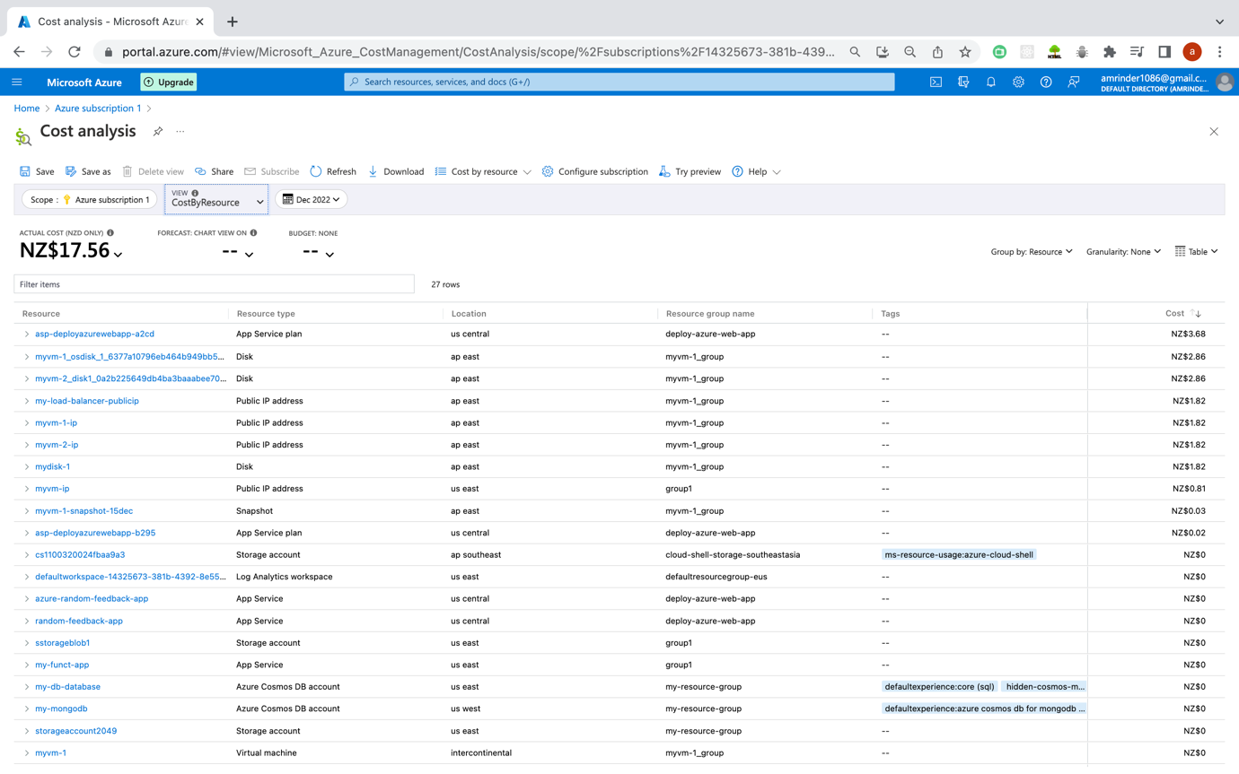

***Accumulated Costs (for 1-2 weeks)***

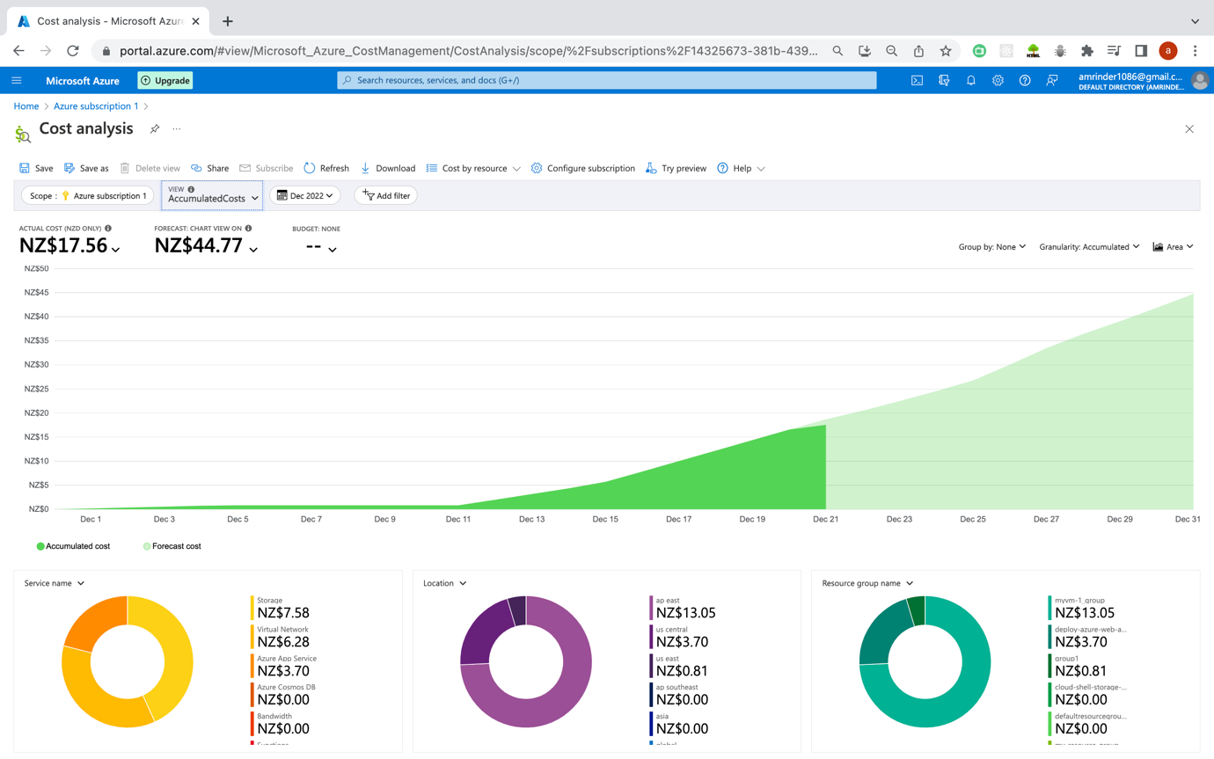

***Daily Costs***

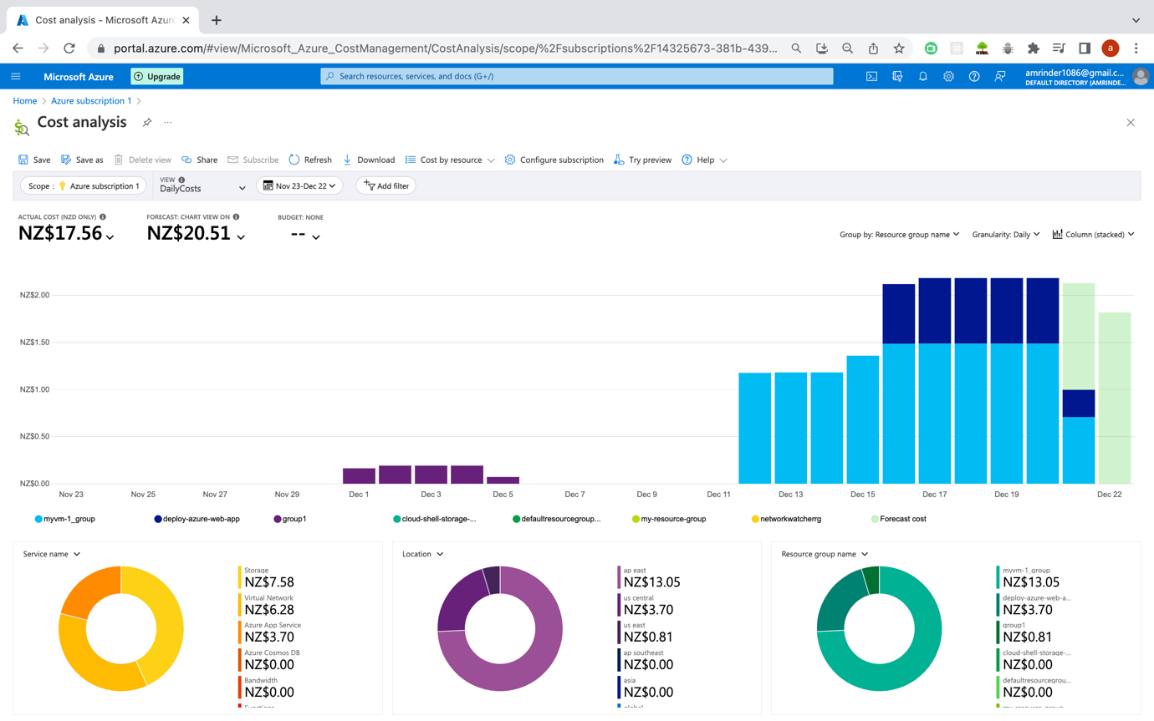

***Resources***

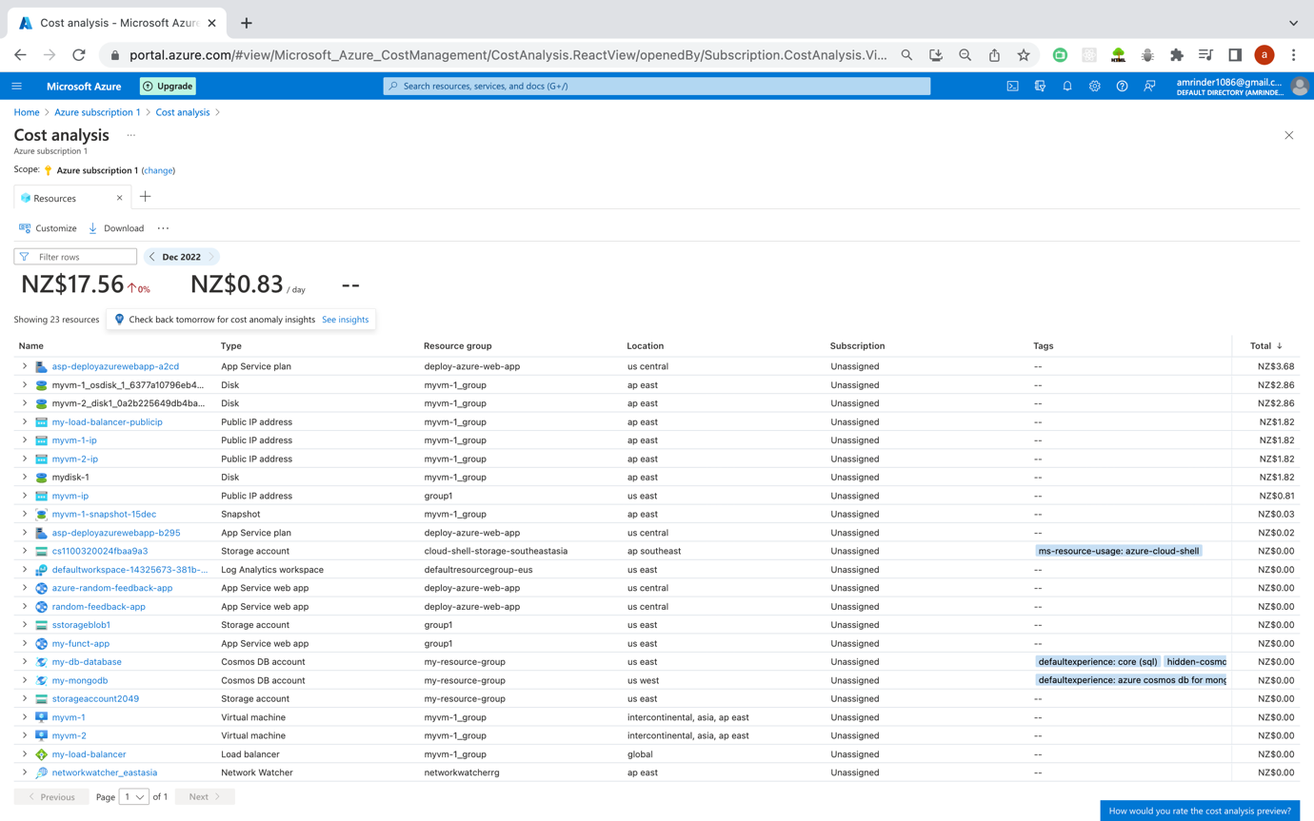

***Mongo DB Web App Usage***

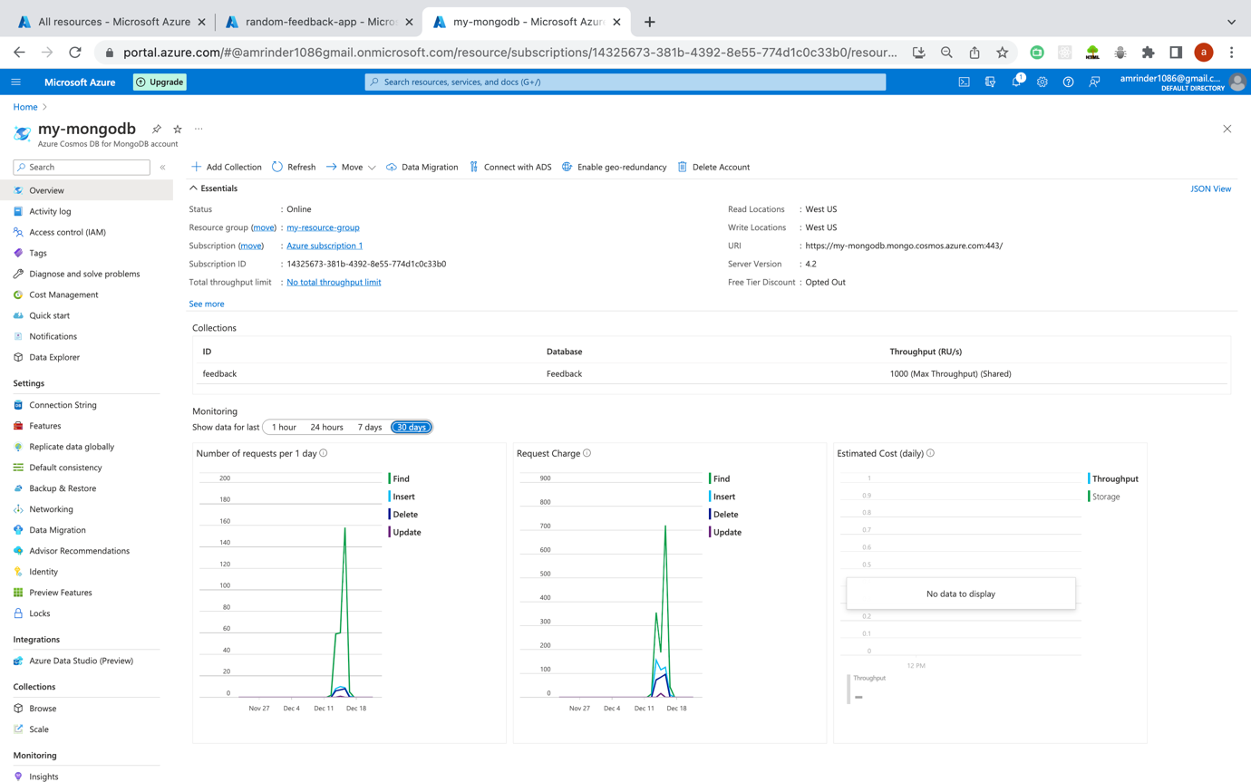

***Subscription Details***

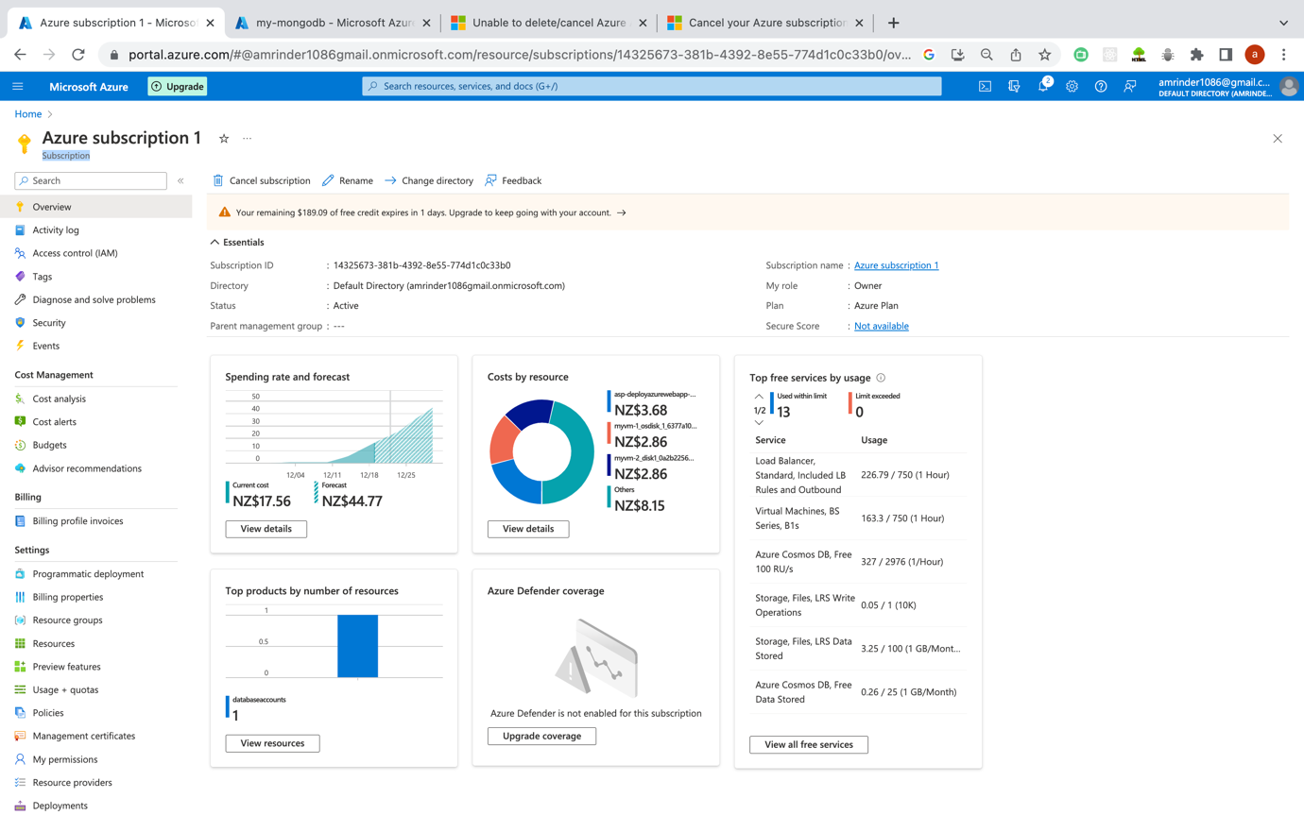

***Subscription Cancelled***

